

Green University of Bangladesh

# Department of Computer Science and Engineering (CSE)

**Faculty of Sciences and Engineering, Semester: Spring, Year: 2024, B.Sc. in CSE (weekend)**

**Lab Report** *#* **01**

**Course Title: Object Oriented Programming Course Code: CSE-202**

**Section: 223 E1 Student Details**

|  |  |  |
| --- | --- | --- |
| **Name** | | **ID** |
| **1.** | **Waliullah** | **223015026** |

**Date : 23-02-2024**

**Submission Date : 08-03-2024**

**Course Teacher’s Name : Abdullah Al Farhad**

**Assignment Status Marks: …………………………………**

**Comments:..............................................**

**Signature:.....................**

**Date:..............................**

# Title: 1. Implement checking of odd and even numbers.

**2. Implement summation of factorial odd number series below this series.**

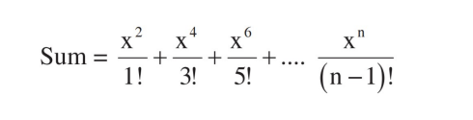

# Introduction:

This program demonstrates two functionalities in Java:

* + **Checking if a number is even or odd:** This is a common task used in various applications for data validation, filtering, and manipulation.
  + **Calculating the sum of the factorials of a series of odd numbers:** This can be useful in mathematical calculations or specific problem-solving scenarios.

# Objective:

This Java program defines three functions:

* + **checkOddEven(num)**: This function checks if a given number is even or odd and returns a string indicating the result.
  + **factorial(num):** This function calculates the factorial of a given number.
  + **factorialSumOddSeries(n and x):** This function calculates the sum of factorials of the **x** and **n**

odd series.

**Example: Below this series**



# Use Case:

* + Checking Odd/Even Numbers:

1. Determines whether an integer is odd or even.
2. Commonly used in various programming applications, data structures, and algorithms.
3. Can be implemented using the modulo operator (%) in most programming languages.
   * Factorial Summation of Odd Numbers:
4. Calculates the sum of the factorials of an odd number series.
5. Has specific use cases in mathematics and computer science, such as generating odd perfect numbers or exploring properties of odd factorials.

# Implementations and Output:

* + **Problem 1:**

**Code:**

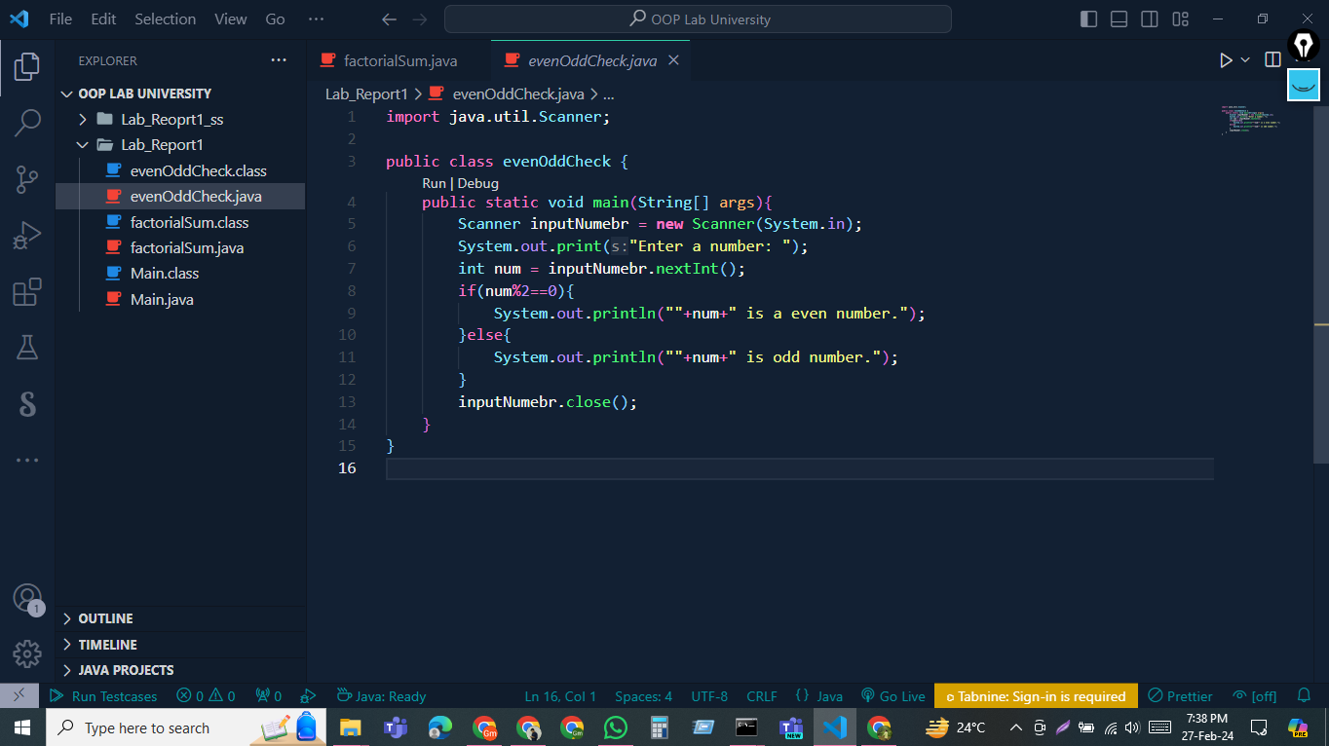

**Output:**

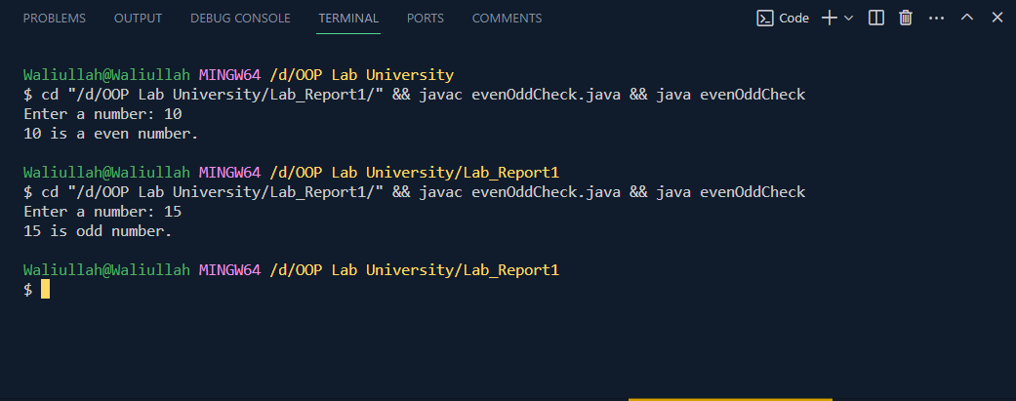

* **Problem 2:**

**Code:**

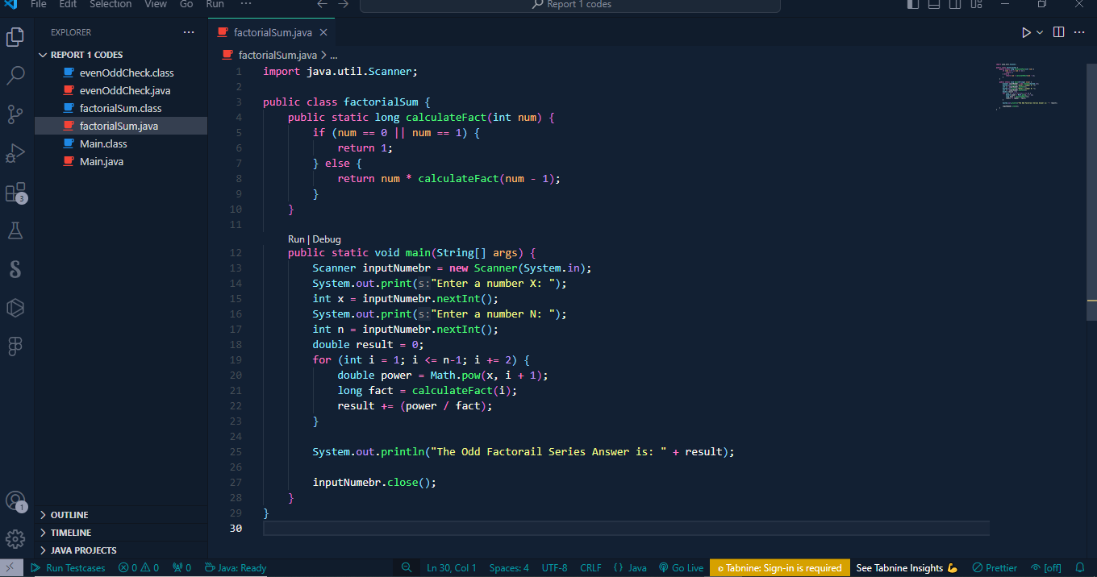

**Output:**

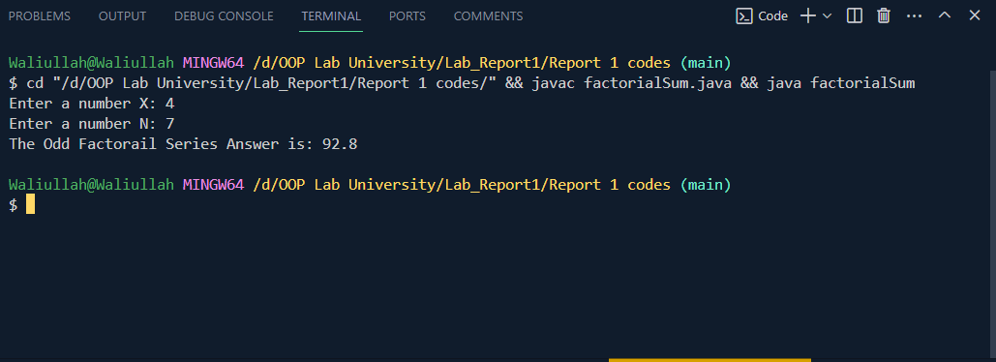

# Limitations:

* + - Integer Overflow: The factorial function can lead to integer overflow for large numbers. Consider using long or a specialized library for big integer calculations.
    - Performance: Repeatedly calculating factorials within the loop can be computationally expensive for large limit values. Explore alternative approaches like pre-computing and storing factorials.
    - Negative Input: The code doesn't handle negative input for checking odd/even and series calculation. Consider adding checks for valid input ranges.

# Conclusion:

This program successfully implements functions to check odd and even numbers and calculates the sum of factorials of odd numbers within a given limit. It demonstrates basic Java control flow, looping, and mathematical operations, providing a valuable solution for these functionalities.